Top 5 Zelda Wind Waker Song

Why not start my Zelda month with the first game I ever played in the Zelda franchise? Almost all of the songs talks to me and when I hear one of them I can almost always tell where it’s from. Almost, there’s some really similar in all of the games. So in fifth place…

Makar’s awakening *: 1 <https://www.youtube.com/watch?v=YLpIAmAE14w&index=106&list=PLZzKhgUfPukDkKAAmlEPfIVvs9cnhOGAr>

Dragon Roost Island *: 3 <https://www.youtube.com/watch?v=zkCopQZWTQ8&index=38&list=PLZzKhgUfPukDkKAAmlEPfIVvs9cnhOGAr>

Sage Raruto : 4

<https://www.youtube.com/watch?v=LVpjfWWRW-A&list=PLZzKhgUfPukDkKAAmlEPfIVvs9cnhOGAr&index=97>

Earth God’s Lyric *: 5 <https://www.youtube.com/watch?v=afn2YXSW_IY&index=99&list=PLZzKhgUfPukDkKAAmlEPfIVvs9cnhOGAr>

Molgera *: 2 <https://www.youtube.com/watch?v=ouqGG7l0ZXQ&list=PLZzKhgUfPukDkKAAmlEPfIVvs9cnhOGAr&index=110>

Wind Waker Title song *: <https://www.youtube.com/watch?v=GG7y0SVAMJ0&list=PLZzKhgUfPukDkKAAmlEPfIVvs9cnhOGAr>

The Legendary Hero : <https://www.youtube.com/watch?v=PVVswCTUPAA&index=3&list=PLZzKhgUfPukDkKAAmlEPfIVvs9cnhOGAr>

Inside a house : <https://www.youtube.com/watch?v=uowEotMlSRU&list=PLZzKhgUfPukDkKAAmlEPfIVvs9cnhOGAr&index=5>

Graandma : <https://www.youtube.com/watch?v=eMjsCOX6S1w&list=PLZzKhgUfPukDkKAAmlEPfIVvs9cnhOGAr&index=16>

Departure from Outset : <https://www.youtube.com/watch?v=7m1QyyKVhzQ&index=18&list=PLZzKhgUfPukDkKAAmlEPfIVvs9cnhOGAr>

Windfall Island : <https://www.youtube.com/watch?v=tvPFHt8xwNs&list=PLZzKhgUfPukDkKAAmlEPfIVvs9cnhOGAr&index=28>

Forest Haven : <https://www.youtube.com/watch?v=NX9yWtVkVKY&list=PLZzKhgUfPukDkKAAmlEPfIVvs9cnhOGAr&index=56>

Hyrule Castle : <https://www.youtube.com/watch?v=oR-39Jt-yoM&list=PLZzKhgUfPukDkKAAmlEPfIVvs9cnhOGAr&index=76>

Princess Zelda’s Theme : <https://www.youtube.com/watch?v=GNd2kPkdO8g&index=90&list=PLZzKhgUfPukDkKAAmlEPfIVvs9cnhOGAr>

Aryll’s Theme : <https://www.youtube.com/watch?v=cVZXoSSOtA4&index=132&list=PLZzKhgUfPukDkKAAmlEPfIVvs9cnhOGAr>

Why not start my Zelda month with the first game I ever played in the Zelda franchise? Almost all of the songs in the series talks to me in a special way and specific ones are really awesome to listen even if you are not playing. When I hear one of them, I can almost always tell where it’s from. Almost, there’s some really similar in all of the games.

So in fifth place…

### Earth God’s Lyric

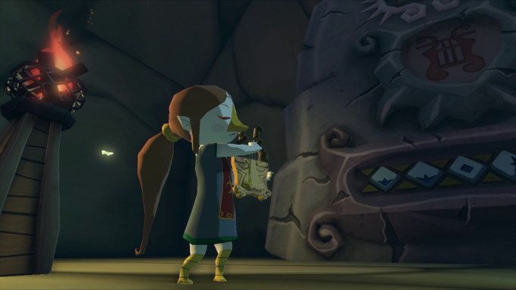

[Link to Youtube](https://www.youtube.com/watch?v=afn2YXSW_IY&index=99&list=PLZzKhgUfPukDkKAAmlEPfIVvs9cnhOGAr)

I like the simple composition and the relaxing tone of it. You hear this song a couple of time from Medli. She plays the song with her harp, and every time you don't need all the big fanfare to make it sound nice.

### Sage Raruto

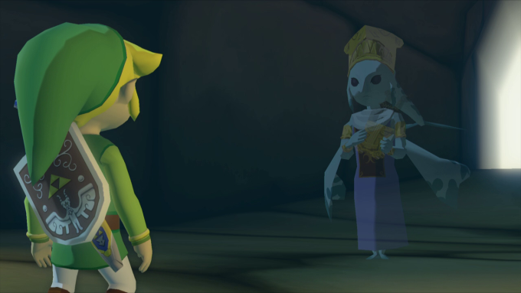

[Link to Youtube](https://www.youtube.com/watch?v=LVpjfWWRW-A&list=PLZzKhgUfPukDkKAAmlEPfIVvs9cnhOGAr&index=97)

This song is similar to the temple of time song in almost all of the Zelda, but I find it has a little more... finesse? The harp brings this song to life and I really like it. It's epic but so clear and smooth.

### Dragon Roost Island

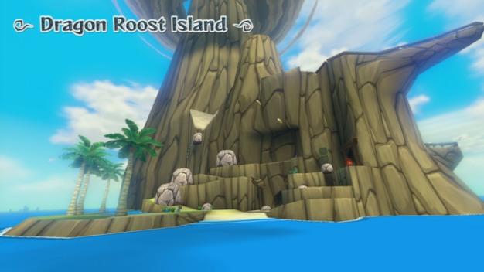

[Link to Youtube](https://www.youtube.com/watch?v=zkCopQZWTQ8&index=38&list=PLZzKhgUfPukDkKAAmlEPfIVvs9cnhOGAr)

This song.... You hear it not so long after starting the game. The song feels warm and the instruments all bring something special to it. You have the palm trees that makes the island look more exotic and I find the people living on it to be more tribal so this song fits perfectly.

### Molgera's Boss Song

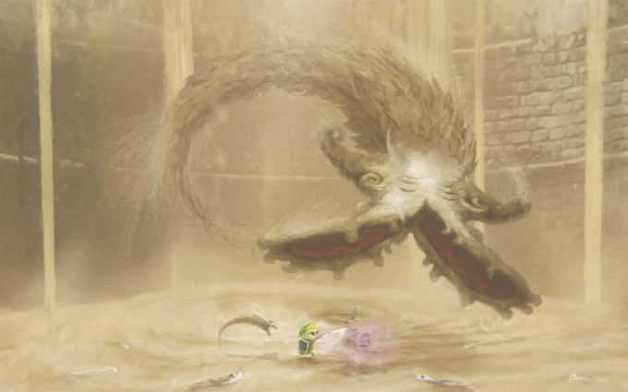

[Link to youtube](https://www.youtube.com/watch?v=ouqGG7l0ZXQ&list=PLZzKhgUfPukDkKAAmlEPfIVvs9cnhOGAr&index=110)

While hearing this song I cannot, I repeat, cannot stop myself from whistling. This boss fight was so nice, the music is unique and it gives you the will to defeat that boss. You felt small and cornered by all the sand creatures that were trying to eat you. I love this song

Here are some

### Makar’s awakening

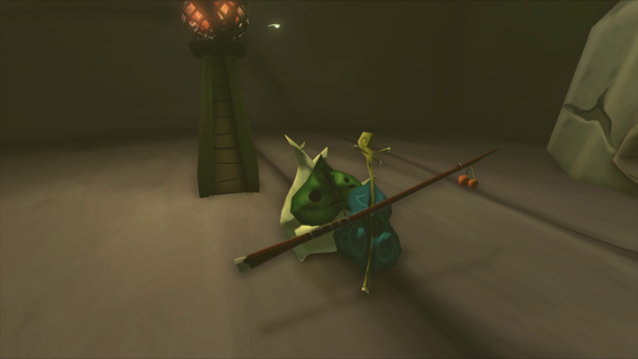

[Link to Youtube](https://www.youtube.com/watch?v=YLpIAmAE14w&index=106&list=PLZzKhgUfPukDkKAAmlEPfIVvs9cnhOGAr)

Yes I know, this song is similar to the wind song and the main title. But this version is calling more to me. It is energic, vibrant and you feel like you could dance to it. It's a shame that it's only 30 seconds long because oh my god it's awesome.

What are your favourite songs from Zelda: Wind Waker? Do you have similarities? I want to know!